**Question 1:**

Create a view to find out what was the % difference in sales of Phones subcategory in 2019 compared to 2018?

1. 34%
2. **33.40%**
3. 32%
4. 36.60%

**Solution -**

Drop the Order Date to the Columns, and drop the Sub-Category to the rows. Now drop the sales to the text so your view would look like this:

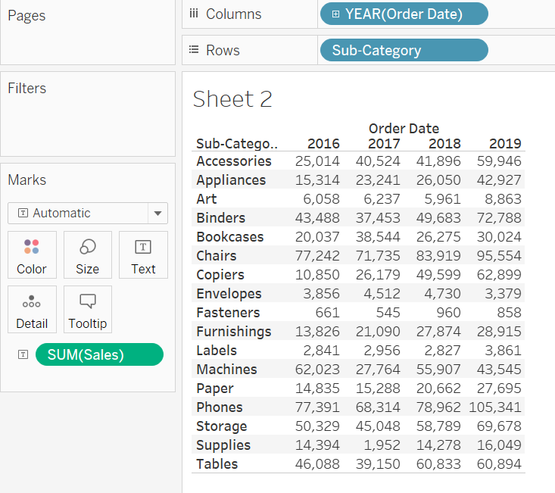

Apply the "Year over Year Growth" Quick table calculation in SUM(sales). So it will look like this:

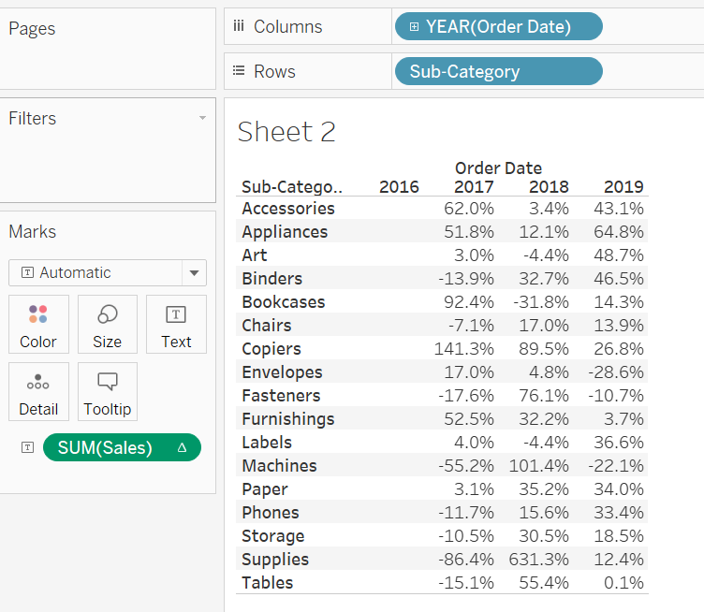

**33.4%** was the difference in sales of Phones subcategory in 2019 compared to 2018.

**Question 2:**

Create a view to find out what was the profit ratio for Technology Category in 2019?

1. **18.65%**
2. 17.23%
3. 18.9%
4. 17.5%

**Solution -**

Create a Calculated field "Profit Ratio" using the formula SUM([Profit])/SUM([Sales]).

Drop Category to Columns, Order Date to Rows, and Profit Ratio to Text. Right-click on profit ratio, click on format, change the Numbers format to percentage. So your final chart would look like this:

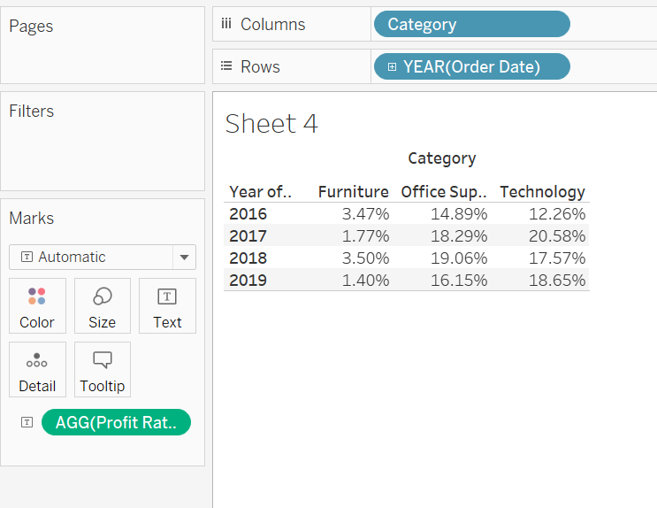

**18.65%** was the profit ratio for Technology Category in 2019.

**Question 3:**

Create a crosstab to find out the average sales of all categories in all regions?

1. 452.7
2. **229.9**
3. 226.5
4. 309.8

**Solution -**

Drop Category to Rows, and drop Region to Columns. Drop Sales to the Text and change the aggregation from SUM to AVG.

Then go to Analysis Menu -> Totals -> Show Row Grand Totals.

Again go to Analysis Menu -> Totals -> Show Column Grand Totals.

Your view would look like this:

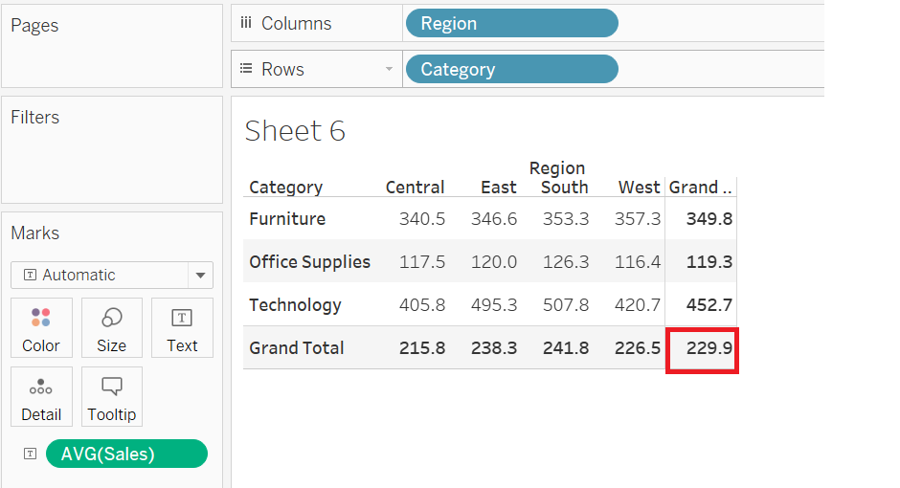

As here we have to find the average of the entire table so **229.9** was the average sales of all categories in all regions.

Question 4:

For any aggregate calculation, can we combine an aggregated value and a disaggregated value?

1. True
2. **False**

Question 5:

Level Of Detail (LOD) filters are executed before context filters?

1. True
2. **False**